Title:
What is PMS vs PMDD, and how do you know the difference?
Keywords:
premenstrual syndrome, PMS, premenstrual dysphoric disorder, PMDD, menstrual cycle, mood swings, irritability, bloating, breast tenderness, fatigue, cravings, emotional symptoms, mental health, anxiety, depression,
Short Description:
PMS and PMDD are often confused, but one is far more serious than the other. Learn how to tell the difference, track your symptoms, and know when it’s time to see a doctor.

What is PMS vs PMDD, and how do you know the difference?
Every month, many women go through physical and emotional changes before their period. For some, it’s mild breast tenderness, tiredness, or feeling easily irritated.
But for others, it’s much heavier. They feel deeply sad, angry, anxious, or even hopeless, and it keeps happening.
In Nigeria, these symptoms are often misunderstood. You’ll hear things like “Is it not just period?” or “You too dey do like say you wan die because of small blood wey dey comot for your bosy.” But sometimes, it’s not ordinary at all.
There is a difference between PMS and PMDD, and knowing where you fall can change how you take care of yourself.
Let’s take a look at what PMS and PMDD are, how to tell them apart, and when it’s time to seek help.
What Is PMS (Premenstrual Syndrome)?
PMS is the collection of physical and emotional symptoms many women experience in the 1–2 weeks before their period starts. It’s incredibly common; studies show that up to 90% of women experience some form of PMS during their reproductive years.
Typical symptoms include:
- Bloating or weight gain
- Breast tenderness
- Headaches or body aches
- Mood swings, irritability, or crying easily
- Fatigue or trouble sleeping
- Food cravings, especially for sweets or salty snacks
For most women, these symptoms are uncomfortable but manageable. They usually ease once menstruation begins and don’t interfere too much with day-to-day life.
However, when these symptoms start affecting your ability to concentrate, maintain relationships, or function normally, it may point to something more than PMS.

What is PMDD (Premenstrual Dysphoric Disorder)?
PMDD is a much more severe form of PMS. It’s not just mood swings or tiredness; it feels like a serious emotional breakdown that shows up every month before your period.
Women with PMDD often experience:
- Deep sadness or depression
- Sudden anger or outbursts
- Anxiety or panic attacks
- Feeling hopeless or worthless
- Losing interest in things they normally enjoy
- Trouble focusing
- Thoughts of self-harm or suicide
It can feel like you’re a different person entirely before your period. Then, once the period starts, the symptoms disappear until next month.
PMDD affects about 3 to 8% of menstruating women. It’s not something you can “snap out of” or pray away. It’s a real medical condition and is recognised as a mental health disorder.
Key Differences at a Glance
PMS and PMDD may happen around the same time in your cycle, but the severity, emotional impact, and life disruption are what set them apart.
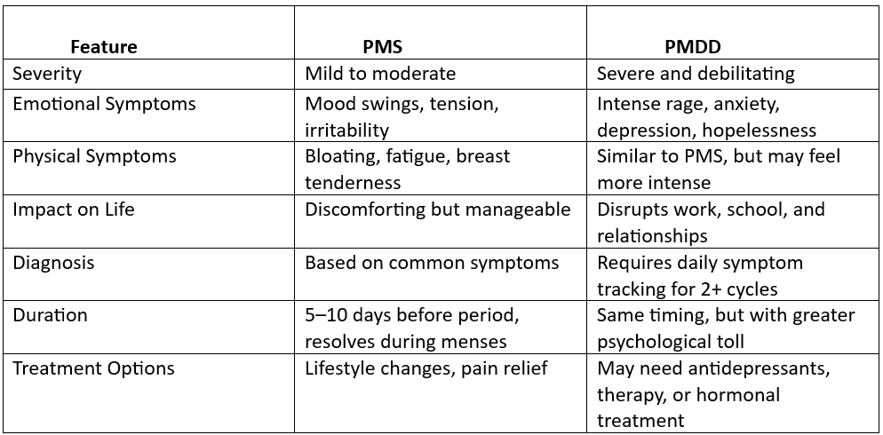

How to Know Which One You Have
The key difference lies in how much your symptoms affect your daily life.
If you feel uncomfortable but can still function, it’s likely PMS. But if your emotions feel overwhelming, and your work, relationships, or mental health suffer every month, PMDD may be the cause.
To know for sure, track your symptoms daily for at least two cycles. Note when they start, how severe they are, and when they ease.
Treatment Options That Work
Let’s take a look at what could help manage each condition in more detail.
For PMS
- Exercise regularly
- Reduce sugar, caffeine, and alcohol
- Use pain relief (e.g., paracetamol, ibuprofen)
- Try supplements like calcium, magnesium, or vitamin B6
For PMDD
- Antidepressants (SSRIs): help balance mood
- Hormonal birth control: to stabilise hormones
- CBT (therapy): to manage emotional symptoms
- In severe cases, hormone-blocking injections may be used
Herbal remedies can help some women, but don’t rely on them alone. Always speak to a doctor
Next Steps
If your pre-period symptoms are so bad that you cry uncontrollably, lash out at people you care about, or feel like disappearing every month, that’s not just regular PMS. It could be PMDD, and it deserves real attention.
Please see a doctor if:
- You feel hopeless, angry, or overwhelmed before your period
- Your symptoms are ruining your relationships or work life
- You’ve had thoughts of harming yourself
- Nothing you’ve tried is helping
You’re not weak. You’re not “too emotional.” And you’re definitely not alone. Getting the right help can change everything.
I’ve said my part. Now I want to hear yours: what does PMS or PMDD look like in your life?

Researched by Victoria Odueso

